EMERGENCY PROCEDURES

The QEII Centre is committed to the safety of all its staff, clients and visitors.

FIRE

The Centre’s Fire Alarm notification is in the form a spoken voice announcement (female) repeating the following:

“A fire has been detected in the building. Please make your way out of the building by the nearest fire exit, please do not use the lifts”.

Familiarise yourself with the FIRE EXITS and FIRE ESCAPE ROUTES from the floors you will be using, and brief any staff/stewards to do so also.

Click icon for the fire exit routes:
On discovering a fire:

- Raise the alarm immediately. Operate the nearest break glass call point.
- Make sure others nearby are aware and that you all evacuate immediately.
- Close doors behind you. Fire extinguishers and other firefighting equipment are to aid exit only. Do not put yourself at any personal risk fighting a fire.
- Do not stop to collect personal belongings.
- Do not use the lifts.
- Once out of the building, make your way to the assembly point.
- Do not re-enter the building until given clearance by the QEII security team.

On being instructed to evacuate via the voice alarm:

- The Voice Alarm will direct you when to evacuate.
- Make sure others nearby are aware and that you all evacuate as directed. Lead nearby building users who may be unfamiliar with the building to the nearest escape route.
- Close any doors behind you. Fire extinguishers and other firefighting equipment are to aid exit only. Do not put yourself at any personal risk fighting a fire.
- Do not stop to collect personal belongings.
- Do not use the lifts.
- Once out of the building, make your way to the assembly point.
- Do not re-enter the building until given clearance by the QEII Incident Control Officer and Security team.
QEII Centre Assembly Points:

Client & Delegates: QEII Lawn
Staff, Tenants & Contractors: Forecourt East
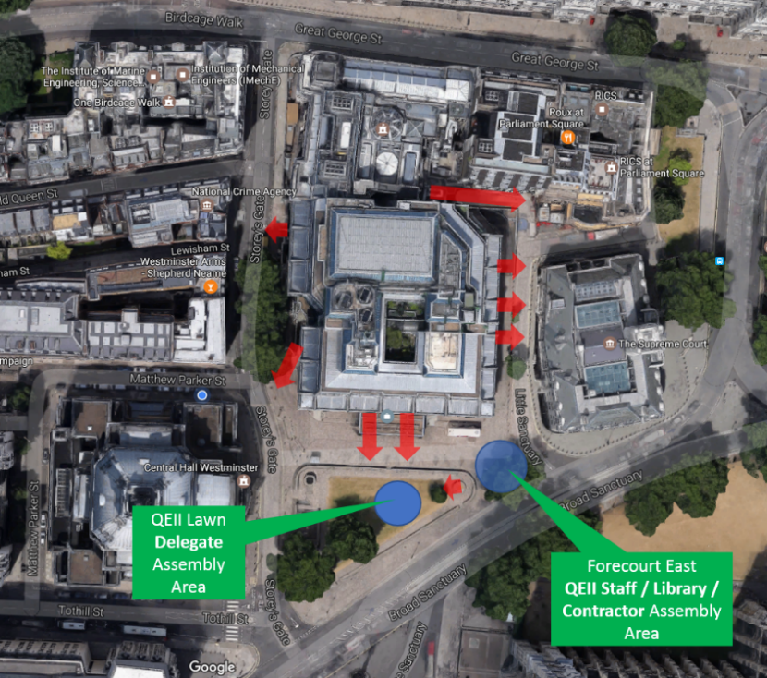

Automatic Actions

When the alarm sounds, the following automatic actions will occur:

1. All electronically locked doors will be freed; this includes any doors, including Fire Exit doors, which may have been secured to restrict access. Doors, which are magnetically retained in the open position, will close automatically and it is for this reason that no door should be wedged open.

2. All lifts will be grounded automatically, and cannot be used once an alarm sounds.

Disabled Personnel

Please inform your Centre Event Manager of any visitor that may need assistance in an emergency situation. Preferably prior to the actual event day in order that a Personal Evacuation Plan (PEP) can be made. A copy of PEP proforma is included with these notes.

MEDICAL

Qualified First Aiders are on site during all events. Should you have a medical emergency notify Security Control on 020 7798 4444 and a First Aider will be despatched. There is a First Aid Room on the ground floor to which First Aiders have access. The First Aider will arrange for an ambulance should this become necessary.

SECURITY

Other incidents, such as a terrorist attack or structural disaster will be acted upon following an assessment of the specific occurrence. For example, the evacuation of delegates from the building following an assessment that there may be a car bomb in an adjacent street may be counter productive. It may be more appropriate to move delegates to a safe area within the building.

Similarly to remain within the building following an assessment that explosive devices are likely to be on site could be catastrophic.

When possible Centre management will make assessments with the cooperation of the police and where time permits event organisers will be included in the process.

An announcement to evacuate will be made via the PA system stating staircases to be used and the designated assembly point. Centre staff will act as floor wardens to assist the process.

Event organisers their delegates and staff are encouraged to notify Security Control on extension 020 7798 4444 should they become suspicious of any activity, bag or package.

Centre security staff would appreciate assistance from event organisers and their staff in establishing a cordon around any suspect item and beginning initial enquires into the identity of the possible owner.

If you have any queries regarding these instructions, please telephone the Security Section:
Dan Blyghton Security Inspector on 020 7798 4053.

EMERGENCY LOCKDOWN PROCEDURE

What is a lockdown?  A lockdown is implemented when there is serious security risk (e.g. violent or armed intruder) to building occupants. The initiating threat can be either internal or external to the building.  How will I know a lockdown is occurring?  You will be notified of a lockdown procedure through one or more of the following:  - Public Announcement (PA) broadcast  - In person notification by police or staff  member  Lockdown Steps  For a building lockdown (Inc. multi occupancy):  - Secure entry and exit points;  - Communicate the threat to tenants and  staff;  - Move immediately to the nearest room you feel is safe with as many people as possible  - Lock and barricade the door and consider  covering windows;  - Turn off the lights or maintain minimal  lighting;  - Move away from windows and doors;  - Lie flat on the floor or take cover out of  sight;  - Turn mobile phones off or to silent;  - Keep calm and quiet; and  - Stay in the room until police arrive.  Remember it may be several hours before you can be safely evacuated.  What if someone is injured?  Follow these steps when safe to do so:  Call 999. If using a mobile please switch it to silent mode. | NB: Do not expose yourself to additional danger in the process of helping others.  Who to call?  Call 999.  What to report?  When contacting authorities, report the following:  - Your specific location, building name and  office/room number;  - The number of people at your specific  location;  - If there are injuries; the number and types  of injuries;  - If you have seen an assailant or identified a  threat:  - location and number of suspects;  - direction of travel;  - their clothing and description;  - their identity if known;  - any weapons or accessories (e.g. backpack);  and any unusual or threatening sounds (e.g. gunfire or explosion)  What if fire alarm sounds?  - DO NOT respond normally as a fire alarm during a lockdown may be a ploy by an armed intruder.  - Remain calm in your lockdown secure area, if safe to do so and attempt to verify fire alarm activation with on-site contact or emergency services.  - If fire is verified, follow Fire/Evacuation procedures.

PERSONAL EVACUATION PLAN
Fire Safety Legislation requires that the managers of this building assess all foreseeable risks from fire and make adequate evacuation arrangements for all persons, including those who may have any physical impairment that may delay them or others from evacuating the building when the fire alarm sounds. This might be because of age or infirmity; pregnancy; hearing or sight impairment or some other physical immobility.
LIFTS
Our building has six floors above ground and if the fire alarm activates most of the passenger lifts will remain on the ground floor and you will not be able to use most of them. If an evacuation is required, you would normally be expected to descend the fire escape stairs to ground level. We have Fire Protected Refuges and Evacuation Chairs. In the unlikely event that you become trapped in a lift please press the alarm button for at least three seconds and carefully follow any instructions you are given.
Step One - HELP US TO HELP YOU
If you are aware of any physical condition that may delay you or other people from evacuating this building in an emergency please tell your own Event Organiser and our Event Manager in the first instance. They will make arrangements to assist you but if you are accompanied by a friend or carer introduce them to us when you arrive. Please read or ask for the Fire Evacuation Instructions displayed around the building to be read to you.
Step Two - CONTACTING US
You can call our security control room 24 hours every day on 020 7798 4040
You can call our Main Reception (8am–7pm Mon-Fri) on 020 7798 4077
You can write to us at the address below at least 48 hours before you are attending.
We will need to know the Date & Name of the Event you are attending.

Step Three – UPON ARRIVAL
We need to assess your condition and using our knowledge of the building and where you may be within it at any time we will consider the impact this may have upon your ability to safely evacuate.
- We will listen to your needs and try to accommodate them safely.
- We will introduce you to one of our trained Fire Wardens and discuss with you some options
- We will show you Fire Refuge Points where you can wait safely with a Fire Warden
- We will show you the nearest Fire Exit Routes to where you will be within the building
- We will show you the location of the Fire Evacuation Lift & Evacuation Chairs
- We will invite you to share with us your personal mobile telephone number if you have one
- We will agree a safe method of evacuation with you. (Please see Page below)

CONFIDENTIAL PERSONAL DETAILS
We invite you to supply your Personal Details so that we can contact you. This is entirely voluntary and any information you supply will only be used for the purposes of arranging a Personal Evacuation Plan within the provisions of the Data Protection Acts. The information will not be passed to any third party and will be destroyed as soon as your attendance at the Centre has finished.
Full Names
Email address
Home Telephone
Mobile Telephone
Age in Years

REASON FOR YOUR ATTENDANCE AT QEII CONFERENCE CENTRE
Date(s)
Between Times
Accompanied? | YES | NO
Companions Details

DESCRIBE THE CONDITION THAT MIGHT DELAY YOUR EVACUATION

FOR CONFERENCE CENTRE USE ONLY
Event Manager Aware
Security Supervisor Aware
Business Centre Aware
Fire Meet & Greet by;
COMMENTS

